GUIDE TO TELEMEDICINE TOOLS FOR YOUR HOME


AGING IN PLACE TOOLS
Authors of the Stay Put! Newsletter

GUIDE TO TELEMEDICINE TOOLS FOR YOUR HOME
March 2024
by
Ezra Nielsen

Aging in Place Tools, Inc. © 2024
Authors of Stay Put! Newsletter

TABLE OF CONTENTS
What You Should Know About This Booklet 1
What Is Telemedicine? 2
How Will Telemedicine Services Meet My Needs? 3

Access To Healthcare Professionals 4
Emergency Response and Chronic Disease Management 8
Hearing And Vision Assistance 15
Nutrition And Personal Care Management 24
Sleep Management and Monitoring 28
Remote Physical Therapy and Monitoring Devices 32
Enhancing Senior Healthcare Through Telemedicine 36

How to Get Started: “Embracing Telemedicine” 37

WHAT YOU SHOULD KNOW ABOUT THIS BOOKLET
This booklet gives an overview of the topic “telemedicine for seniors in their homes.”
All decisions related to medical needs and care should be researched carefully.
This booklet is intended to give examples of products that serve a variety of needs. The selection mentioned in this booklet does not represent all available products, nor is it meant to recommend certain products over others.
As product and service specifications change, this booklet may have information that is no longer up to date. Always consult with product vendors for the latest information, features and pricing.
This booklet will provide you with links to mentioned products for convenience. Please take your time and consult with your families, friends, healthcare professionals, and product vendors when making important decisions.
Thank you,
The Team at Aging In Place Tools

WHAT IS TELEMEDICINE?
Telemedicine is having a doctor’s visit without leaving your cozy armchair. Instead of trekking to the clinic, you chat with your doctor using a computer or smartphone. They can see your face and hear your voice, just like when your grandkids call you.
You can discuss your aches, pains, and mysterious twinges right from your living room. No need to shuffle through waiting rooms or brave the chilly outdoors. So, next time you’re feeling a bit under the weather, just hop onto that device of yours. Telemedicine to the rescue!


"Telemedicine can give some specialty practitioners an advantage because they can see you in your home environment."
—Johns Hopkins Medicine
"COVID-19 has pushed us to try new approaches...Patients have become more proficient with technology for telemedicine."

"The biggest benefit of telemedicine is that we can offer subspecialized care to the right person in the right place at the right time."
—Mayo Clinic

How Will Telemedicine Services Meet my Needs?
Telemedicine services provide access to healthcare professionals, emergency response services, remote hearing and vision assessments, and monitors for managing your health at home. By meeting these needs without an in-person doctor’s visit, telemedicine offers convenient options to maintain and monitor your health.
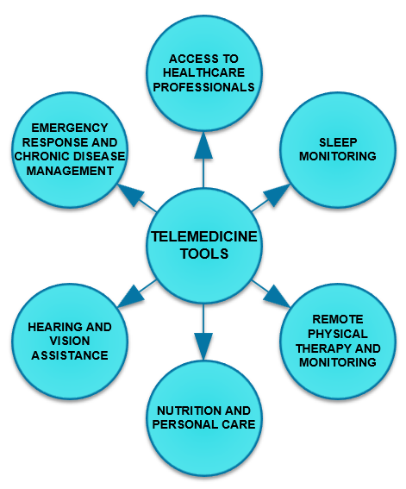


This section shows examples of products and services related to the following concerns you may have:
- Regular check-ups and treatment for common illnesses
- Support and care for mental well-being
- Maintaining a healthy sexual life
- Managing long-term health conditions like diabetes or heart disease
- Advice and guidance on eating well for better health
Telemedicine platforms connect you with healthcare professionals without leaving your home. These platforms make healthcare accessible. Whether you’re tech-savvy or still figuring out your smartphone, you can be confident in using them.
HealthTap and Teladoc are two telemedicine platforms recommended for seniors:
- HealthTap has a membership fee of $15 per month (without insurance) as well as a visit fee of $44 (visit fees are paid each time you have a consultation).
- Care offered:
  - Chronic condition management
  - Women’s health
  - Children’s health
  - Men’s health
  - Senior health
  - Wellness care
  - Prevention and lifestyle
  - Sexual health
  - Mental and behavioral health
  - Travel medicine
  - Urgent care
How to book an appointment:
- Click this link to the HealthTap website.
- Click the blue “Book a Video Appointment” button in the top right corner of the screen.
- Follow on screen instructions.
Here’s a screenshot of the HealthTap website with a cursor indicating the “Book a Video Appointment” button:
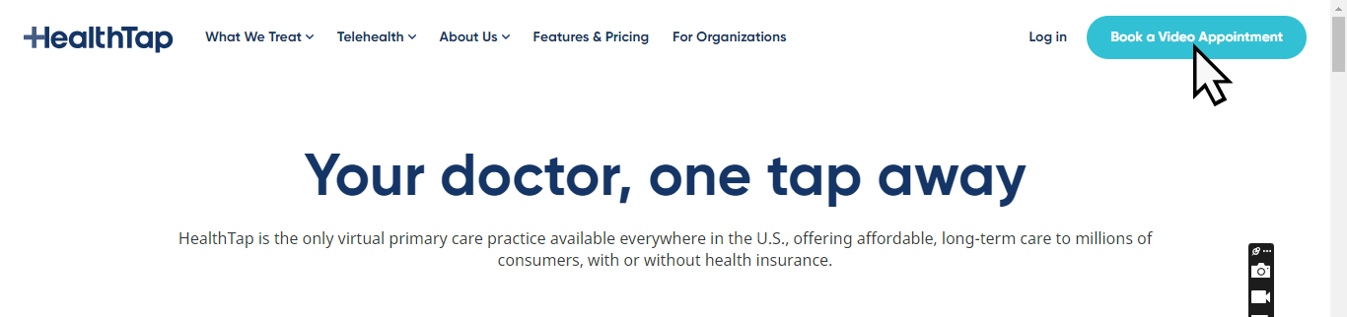
- Teladoc has no membership fee but requires a visit fee of $75.
- Care offered:
  - General medical
  - Primary 360 (routine primary care visits)
  - Mental health
  - Specialist and expert opinion
  - Wellness care (such as nutrition and sexual health)
How to book an appointment:
- Click this link to the Teladoc website.
- Click the purple “Register now” button in the top right corner of the screen.
- Follow on screen instructions.
Here is a screenshot of the Teladoc website with a cursor indicating the “Register now” button:


FIVE POPULAR TELEMEDICINE PLATFORMS:
Platform | Pricing | Key Benefits
HealthTap | $15 per month | Educational Q&A  Personalized treatment plans
Teladoc | General: as low as $0 with insurance  Therapy: $0-99 | Available in all 50 states.  Chronic care management and health-tracking devices.
Maven | Physician: $40 for 10 minutes  Lactation consultants, doulas, physical therapists, nutritionists: $25 for 10 minute appointment  Mental health care providers: $20 for 10 minute appointment (first week only) | Virtual support groups.  Savings for Sesame Plus members
PlushCare | General: Typically $30 out-of-pocket cost  Therapy: $169 per session | Same-day appointments available.  Various specialists available
Sesame Care | Online Therapy: $19+ per session.  Sesame Plus Membership: $10.99/month or $99/year | Both virtual and in-person therapy.  No insurance needed.

EMERGENCY RESPONSE AND CHRONIC DISEASE MANAGEMENT
(FROM YOUR HOME!)


This section shows examples of products and services related to the following concerns you may have:
- Quick response and assistance in emergencies
- Preventing and responding to falls
- Monitoring daily activities and changes in behavior for signs of health issues
- Keeping an eye on vital signs like blood pressure and heart rate
- Alerting others to your needs
- Supporting memory and cognitive function
- Managing heart health and preventing heart-related issues

The MobileHelp Classic wearable alert system provides security without compromising your everyday routine (Image Source)
Emergency response and chronic disease management are crucial aspects of your well-being. Having emergency plans in place helps you connect with others, receive assistance, and stay informed.
Approximately half of individuals over the age of 65 have two or more chronic health conditions that may require regular medication, monitoring, and specialized care. Managing chronic diseases involves staying informed about your condition, adhering to treatment plans, and having access to necessary medications.
Telemedicine tools such as Livindi and EnvoyatHome provide remote monitoring services:
- Livindi:
- Provides an in-home connected care platform that supports both mental and physical wellness
- Offers Medicare-covered virtual therapy. Licensed therapists are available to support you from the comfort of your home.
- The monitoring kit includes a tablet and a combination of activity sensors, biometrics, wearables, and more based on your needs.
- Helps you monitor vitals such as pulse, blood pressure, SpO2, temperature, weight, respiration, and heart rate variability. Also tracks your sleep quality and notifies you when you get in and out of bed.
- Offers fall detection, a call button to reach your care team, and activity monitoring using sensors and artificial intelligence.
- EnvoyatHome:
- Uncovers subtle changes in your behavior at home 24/7. It replaces guesswork with actionable information.
- Unlike traditional systems, EnvoyatHome doesn’t rely on wearables or cameras. It monitors your behavior, not just your location.
- When you’re at risk, EnvoyatHome alerts caregivers.
MobileHelp and Medical Guardian provide alert systems with built-in fall detection to ensure your safety:
- MobileHelp Classic (MobileHelp Product):
- Average response time of 25–50 seconds.
- Covers a range of 600–1,400 feet.
- Up to 3 days of battery life
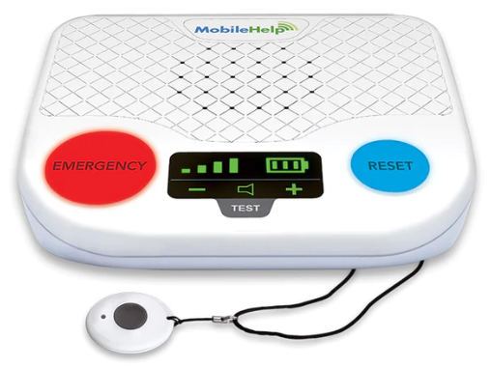
- MGClassic (Medical Guardian Product):
- Average response time of 1–25 seconds.
- Covers a range of 1,300–1,400 feet.
- Up to 5 days of battery life.
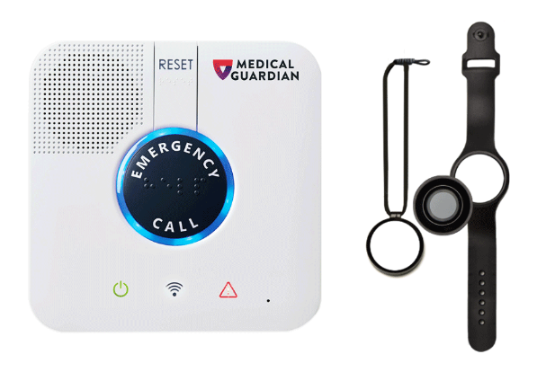

Products like Jiobit, a GPS tracking tag, can be used to ensure safety through location monitoring of individuals with Dementia:
Jiobit:
- Small and discreet so you won’t feel burdened by wearing it.
- Send an instant alert to your caregivers if you need assistance with the Jiobit button.
- Allows you to build care teams. Add other caregivers or family members to receive the same alerts and tracking capabilities.
- Provides SOS Mode (from Noonlight). In emergencies, it notifies your care team and sends emergency details, including the current location, to professional dispatchers who will contact you immediately.
Jiobit device beside cracker for size comparison:
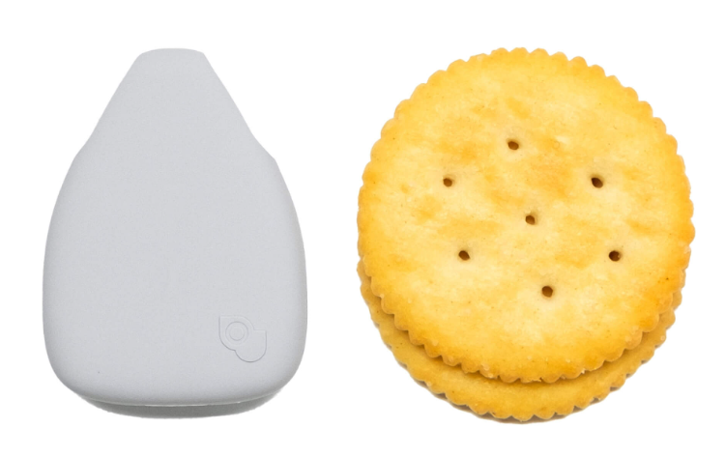
Biometric monitoring devices, or devices that measure vital signs such as heart rate or blood pressure, can also aid in monitoring chronic conditions like heart disease.
- Garmin Vivosmart 4:
- Activity and fitness tracker
- Pulse oximeter and heart rate monitoring features.
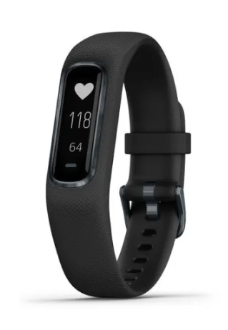
- Omron 5 Series Wireless Upper Arm Blood Pressure Monitor:
- Clinically validated and FDA-cleared
- Provides accurate readings
- Stores up to 60 readings
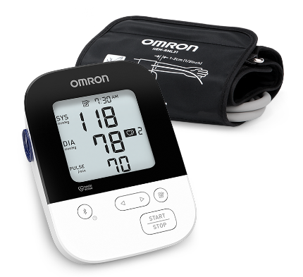

POPULAR EMERGENCY AND MEDICAL MONITORING PRODUCTS:
Remote Monitoring Service | Summary | Key Benefits
Livindi | Blends wireless monitoring and two-way video chat with specially trained caregivers | Vital and sleep pattern tracking, medication reminders
EnvoyatHome | Real-time monitoring without wearables or cameras | Vital and sleep pattern tracking, video chat
Rest Assured | Provides remote monitoring technology with real-time support | Vital, sleep pattern, and meal prep monitoring
Aloe Care Health | Smart home system with voice-activated emergency alerts | Activity tracking, medication reminders
SMPL Alerts | Wearable emergency button | Location tracking, two-way communication

Alert Devices | Response Time (in seconds) | Range (in feet) | Battery Life (up to…)
MobileHelp | 25-50 | 600-1400 | 3 days
Medical Guardian | 1-25 | 1300-1400 | 5 days
Bay Alarm Medical | 1-25 | 1000 | 6-18 hours
LifeFone | 1-25 | 1300 | 30 days
GreatCall Lively Mobile Plus | Average: 13 | Wherever cell service is available | 80 days
Philips Lifeline | Average: 12 | 500 | 72 hours

Disease Management Device | Function/Benefits | Chronic Disease
Jiobit | GPS Tracker | Dementia
Polar H10 Heart Rate Sensor | Heart rate monitoring during workouts | Heart Disease
Garmin Vivosmart 4 | Activity and fitness tracker with pulse ox and heart rate monitoring | Heart Disease
iHealth Track Blood Pressure Monitor | Stores up to 99 readings on the device | Heart Disease
Omron 5 Series Wireless Upper Arm Blood Pressure Monitor | Provides accurate measurements and stores up to 60 readings | Heart Disease
Microlife Deluxe Blood Pressure Monitor | Reliable blood pressure monitor with simple design | Heart Disease
A&D Medical Premium Pre-Formed Cuff Blood Pressure Monitor | Comes with a pre-formed cuff for ease of use | Heart Disease
FORA Test N’GO Wireless Bluetooth Upper Arm Blood Pressure Monitor | Portable design with Bluetooth connectivity | Heart Disease

HEARING AND VISION ASSISTANCE


This section shows examples of products and services related to the following concerns you may have:
- Decreased social engagement
- Missing emergency audio cues
- Limited awareness of surroundings
- Needing an accessible hearing test

The OrCam MyEye 3 Pro conveniently latches to your eyeglasses to provide audio descriptions of your surroundings (Image Source)
Hearing and vision assistance tools can be a vital turning point for your well-being. Staying socially connected is essential for everyone’s health. However, age-related hearing loss and vision impairment can increase social isolation. These tools empower you to maintain connections, engage in social activities, and enjoy life to the fullest.
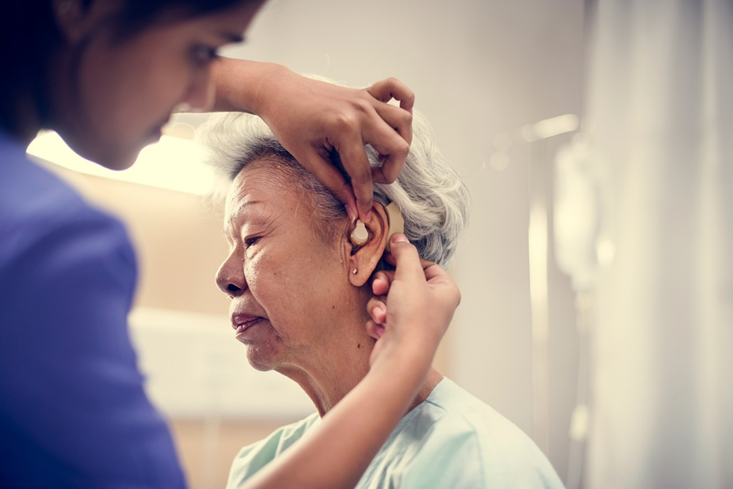
Hearing Aids are available in multiple styles including receiver-in-canal (RIC), in-the-ear (ITE), in-the-canal (ITC), completely-in-canal (CIC), and invisible-in-canal (IIC) depending on your needs and preferences (Image Source)
- Hearing aids enhance your ability to hear and understand conversations so you can connect and engage with your loved ones.
Let’s compare two recommended hearing aids:
  - Phonak Audéo Lumity:
    - Starting price for a pair: $2,498.
    - Style: Receiver-in-canal (RIC).
    - Appropriate for: Mild, moderate, severe, and profound hearing loss.
    - Why We Picked It: Rich sound quality and suitable for various levels of hearing loss.

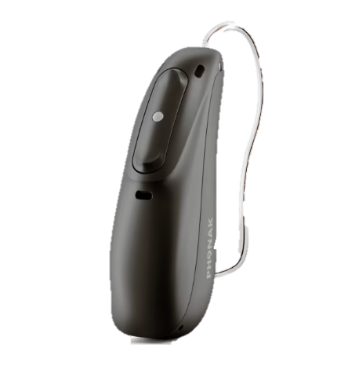
  - Jabra Enhance Plus:
    - Starting price for a pair: $799.
    - Style: In-the-ear (ITE).
    - Appropriate for: Mild and moderate hearing loss.
    - Why We Picked It: Nearly invisible design and convenient follow-up care from Jabra Enhance’s audiology team.
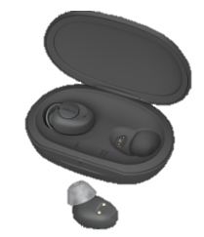
- Remote Hearing Tests allow you to assess your hearing without leaving home. While they don’t replace professional diagnosis, they provide valuable insights.
Let’s explore some of the top options:
- Phonak Online Hearing Test:
  - Test Time: Approximately three minutes.
  - Equipment Needed:
    - Computer or smartphone
    - Internet access
    - Headphones
  - Accuracy: Phonak’s online hearing test boasts 90% accuracy. It was designed by a team of engineers and researchers to effectively screen hearing.
  - User-Friendly: The test provides clear instructions and considers technical difficulties such as headphone placement.
  - Results: After completing the test, you’ll receive personalized results.
Take the test:
- Click this link.
- Click the “Online hearing test” text in the top right corner of the screen.
- Click the green “Let’s start!” button at the bottom of the screen.
Phonak website with a cursor indicating the “Online hearing test” text:

Phonak website with a cursor indicating the “Let’s start!” button:
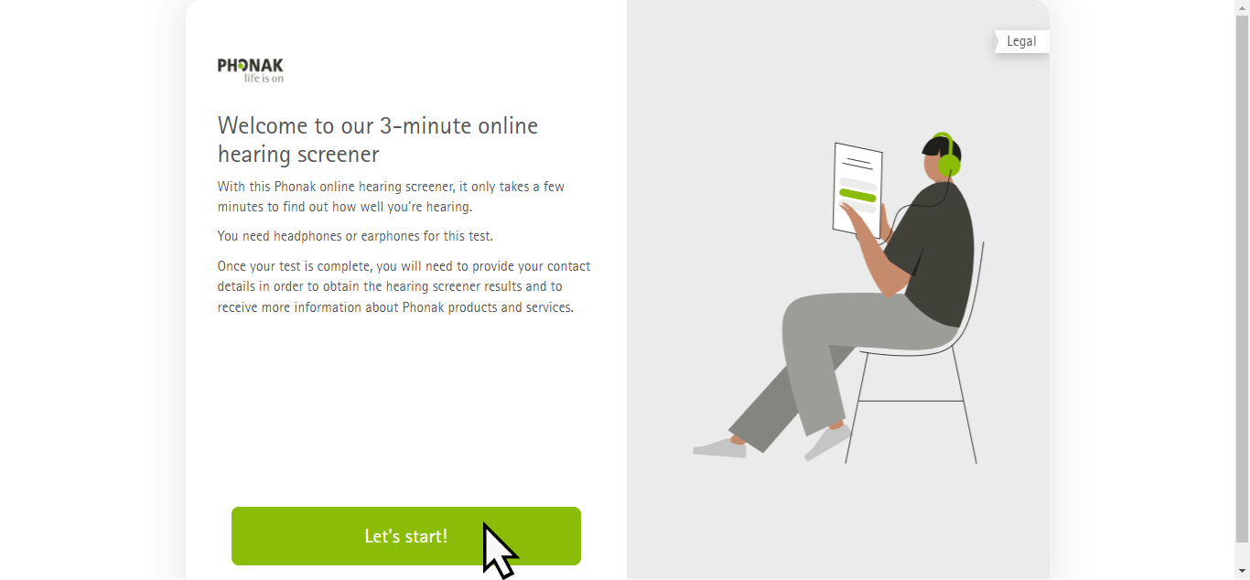
- ReSound Online Hearing Test:
  - Test Time: Takes less than five minutes to complete.
  - Equipment Needed:
    - Computer or smartphone
    - Internet access
    - Headphones
  - Purpose: This test helps identify difficulties with understanding speech in noisy environments.
  - Procedure: You’ll hear different combinations of words and numbers while background noise varies. Select the corresponding icon or number based on what you hear.
  - Note: While this test is not a full audiological assessment, it serves as a validated audiological screener.
Take the test:
- Click this link.
- Click the red “Take the Online Hearing Test” button in the lower right portion of the screen.
- Click the red “Get started” button at the bottom of the screen.
Resound website with a cursor indicating the “Take the Online Hearing Test” button:
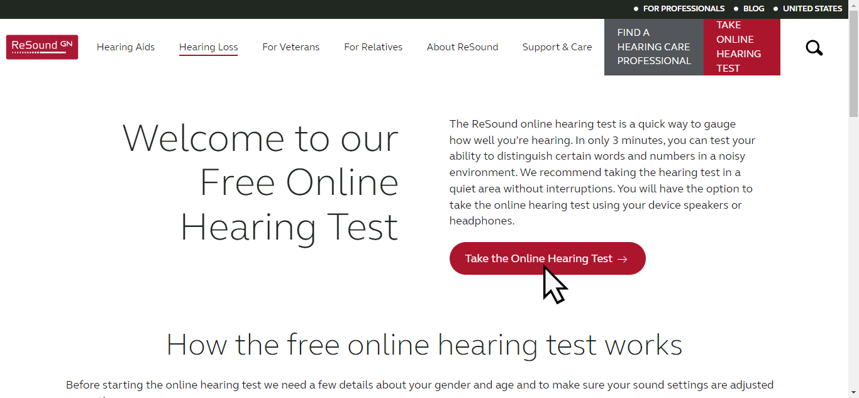
Resound website with a cursor indicating the “Get started” button:
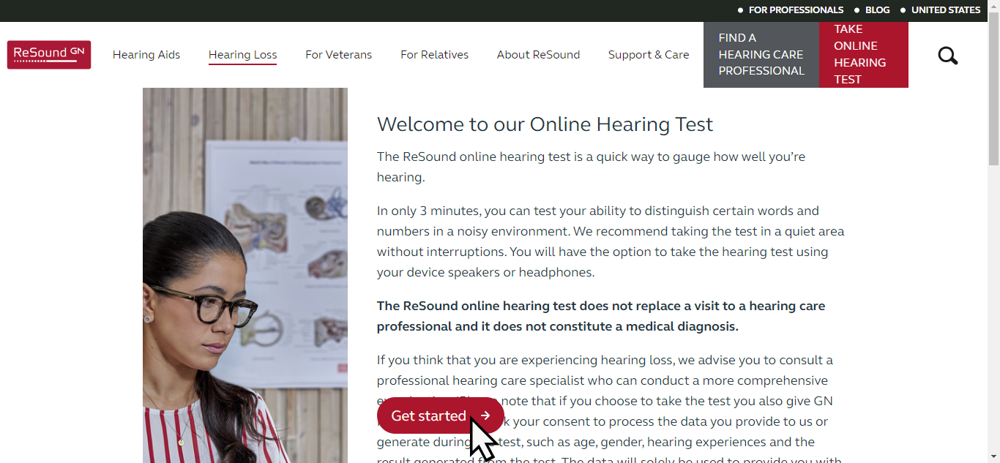
- Vision Care Devices are designed to assist with vision loss. These devices can significantly enhance your independence and quality of life.
  - OrCam MyEye 3 Pro:
    - A small wireless smart camera that attaches magnetically to the arm of any eyeglasses.
    - Functionality:
      - Captures images of the surroundings.
      - Communicates information audibly through a tiny speaker near the ear.
      - Reads text, scans barcodes, identifies currency denominations, and memorizes everyday objects.
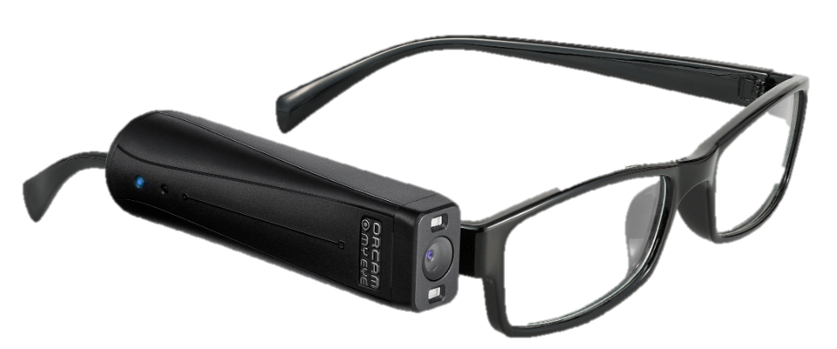
  - eSight 4:
    - Description: Electronic glasses that enhance vision for people who are legally blind or have low vision.
    - Features:
      - Provides real-time video magnification.
      - Improves visual acuity (some users report going from 20/600 to 20/20 vision).
      - Enables better recognition of faces, text, and objects.
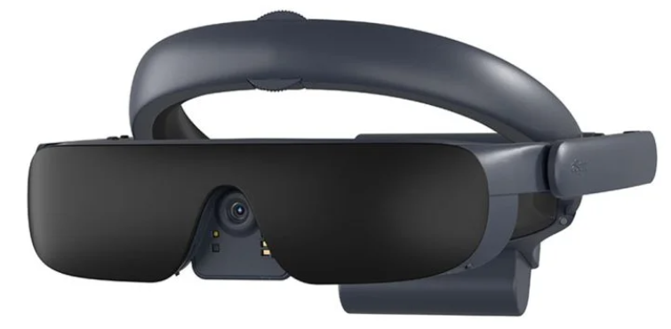
- Vision Care Apps are designed for people with low vision and offer spatial orientation and audio guidance. They enhance independence and social participation.
Here are some top-rated free vision care apps and resources:
- Seeing AI:
  - Narrates the world around you by using your phone’s camera.
  - Identifies objects, reads currency, and even deciphers handwritten cursive.
- Lookout:
  - Provides spoken feedback about your surroundings.
  - Uses the camera and sensors to recognize text, people, and objects.
- Be My Eyes:
  - Connects visually impaired individuals with sighted volunteers via live video calls.
  - Volunteers assist with tasks like reading street signs or troubleshooting technology.

POPULAR HEARING RESOURCES:
Hearing Aid | (Starting) Price | Supported Hearing Loss Levels
Phonak Audéo Lumity | $2498 | Mild to Profound
Jabra Enhance Plus | $799 | Mild to Moderate
Phonak Naída Paradise | $2798 | Mild to Profound
Starkey Genesis AI | $2798 | Mild to Profound

Hearing Test | Test Time | Key Information
Phonak Online Hearing Test | Approximately 3 minutes | Provides clear instructions  90% accurate
ReSound Online Hearing Test | Less than 5 minutes | You’ll hear different words and numbers as background noise varies
Go Hearing Free Online Hearing Screener | Less than 2 minutes | Numbers are presented with background noise

POPULAR VISION RESOURCES:
Vision Care App/Device | Price | Function
OrCam MyEye 3 Pro | $4250 | Wireless smart camera that attaches to the arm of your eyeglasses and describes surroundings as audio
eSight 4 | $6950 | Electronic glasses that enhance vision
Seeing AI | Free | Narrates the world around you with your phone’s camera
Lookout  (Google Play) | Free | Provides spoken feedback about your surroundings
Be My Eyes | Free | Connects visually impaired individuals with volunteers through video calls
Aira | Subscriptions starting at $65 | Connects trained agents to people with vision impairments
Supervision+ Magnifier  (Google Play)  (App Store) | Free | A magnifying app designed for iPads and iPhones


This section shows examples of products and services related to the following concerns you may have:
- Ensuring a balanced diet tailored to health conditions
- Maintaining physical activity suited to individual capabilities and health needs
- Eating guidance that accommodates specific dietary needs and restrictions
- Techniques to reduce stress and promote relaxation
- Practices to enhance mental well-being and focus
- Keeping track of health discussions for better understanding and follow-up
- Activities designed to enhance memory and cognitive health
Prioritizing your nutrition and personal care as you age is crucial. Proper nutrition supports overall health by providing your body essential vitamins, minerals, and nutrients. Monitoring your food intake helps prevent weight fluctuations, which impact joint health and cardiovascular function.
Personal care routines contribute to self-esteem and mental health. Participating in activities that use critical thinking and logic engages your brain to keep it healthy—much like exercise for your mind.
- Nutritional tracking apps help you monitor your food intake, stay hydrated, and maintain a healthy diet.
- MyFitnessPal:
  - Allows users to track their food intake and exercise.
  - Features:
    - Comprehensive database: Access to a vast library of food items for accurate tracking.
    - Calorie counting: Monitor daily caloric intake.
    - Exercise tracking: Log physical activity.
How to sign up:
- Click this link.
- Click the white “START TODAY” button in the bottom left portion of the screen.
MyFitnessPal website with a cursor indicating the “START TODAY” button:
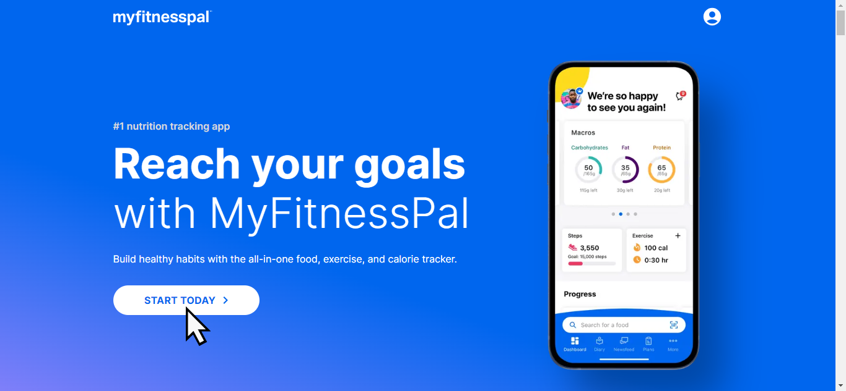
- Fooducate:
  - Helps users make healthier food choices.
  - Features:
    - Nutrition grades: Evaluate food products based on their nutritional value.
    - Personalized recommendations: Tailored to individual dietary preferences and restrictions.
How to sign up:
- Click this link.
- Click the green “Get Started” button in the bottom left portion of the screen.
Fooducate website with a cursor indicating the “Get Started” button:
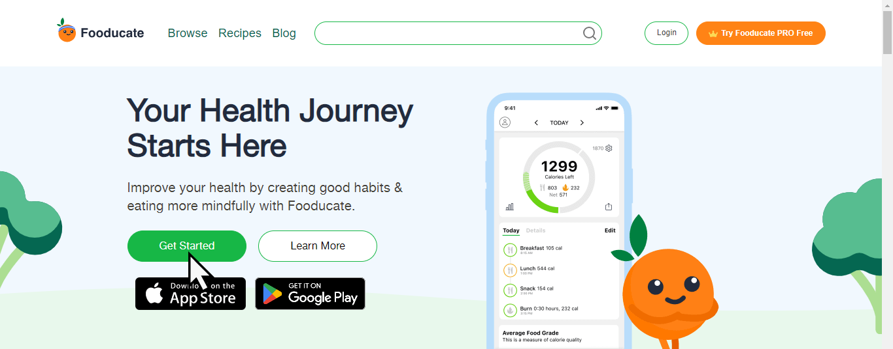

- Personal Care Apps enhance well-being, provide support, and promote healthy living. These apps cater to various needs from summarizing medical conversations to mental health.
- Calm:
  - Originally a meditation app, Calm has expanded to offer more than meditation.
  - Provides:
    - Relaxation techniques
    - Sleep stories
    - Mindfulness exercises
  - Helps with managing stress and improving overall well-being.
- Abridge:
  - Useful for recording and summarizing medical conversations.
  - Helps you and your caregivers keep track of important health information.
  - Available for both Android and iOS devices.
- Lumosity:
  - A brain-training app that offers games and exercises to improve cognitive function.
  - Helps you keep your mind active and engaged.

POPULAR NUTRITION AND PERSONAL CARE RESOURCES:
Platform | Summary | Features
MyFitnessPal | Track food intake and exercise | Vast library of food items  Calorie and exercise tracking
Fooducate | Make healthier food choices | Food product nutrition grades  Personalized meal recommendations
Yummly | Provides personalized recipe recommendations | Customized recipes and meal planning
Noom | Focuses on behavior change and weight loss | Behavioral coaching and food logging
Mealime | Simplifies meal planning and grocery shopping | Customizable meal plans and grocery list generator

Personal Care App | Summary | Features
Calm | Helps you manage stress and improve overall well-being | Relaxation techniques  Sleep stories  Mindfulness exercises
Abridge | Keep track of important health information | Recording and summarizing medical conversations
Luminosity | Keeps your mind active and engaged | Games and exercises to improve cognitive function

SLEEP MANAGEMENT AND MONITORING


This section shows examples of products and services related to the following concerns you may have:
- Monitoring sleep patterns to ensure restful nights
- Observing vital signs to identify sleep-related health issues
- Regular physical activity tailored to improve sleep quality
- Using calming sounds to facilitate a deeper sleep
- Employing guided meditation techniques to help relax the mind for better sleep
Sleep tracking devices and sleep health apps offer valuable assistance in monitoring and managing your sleep, leading to better health and vitality. Consult with a healthcare professional for personalized advice on improving sleep quality.
- Sleep Tracking Devices are gadgets designed to monitor your sleep patterns and provide insights into your sleep quality.
  - Oura Ring: Image Source
    - Lightweight design
    - Captures an impressive range of sleep data metrics throughout the day and night, including:
      - Daily sleep score
      - Heart rate
      - Body temperature
      - Blood oxygen levels
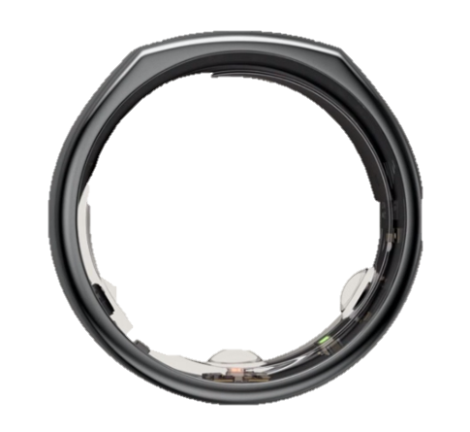
  - WHOOP 4.0:
    - This wristband is ideal for active individuals.
    - Tracks:
      - Sleep patterns
      - Heart rate variability
      - Exercise
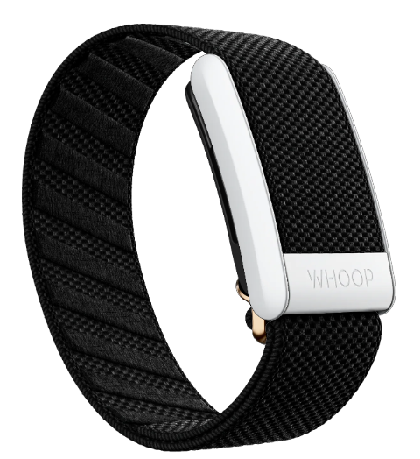
- Sleep Health Apps provide tools and insights to improve your sleep.
  - BetterSleep:
    - Offers a wide variety of soothing sounds. You can choose calming melodies, white noise, or nature sounds to help you relax and fall asleep.
    - Monitors your sleep patterns
    - Provides insights into your sleep duration, interruptions, and overall sleep quality.
  - Sleepiest:
    - Provides a diverse range of sleep support content. From guided meditations to relaxing stories, it caters to different preferences and helps you wind down effectively.
    - Includes sleep tracking features so you can gain valuable insights into your sleep habits and make informed adjustments.

POPULAR SLEEP MANAGEMENT AND MONITORING RESOURCES:
Sleep Tracking Device | Summary | Best…
Oura Ring | Measures heart rate, body temperature, and blood oxygen levels | Lightweight design
WHOOP 4.0 | Tracks sleep and exercise | For active individuals
Rise Science Sleep Tracker | Detailed analysis to optimize sleep quality | Sleep reports
Sleepon Go2sleep Tracker | Monitors blood oxygen levels | Oxygen level tracker
Bía Smart Sleep Mask | Measures sleep patterns and provides insights | Multipurpose tracking
Muse S Headband Sleep Tracker + App | Tracks sleep metrics | Features  (Guided meditation and sleep coaching)
Withings Sleep | Monitors sleep cycles, heart rate, and snoring | Non-wearable option

Sleep Health App | Summary | Best…
BetterSleep | Soothing sounds and sleep tracking | Sound library
Sleepiest | Calming meditations and sleep tracking | Sleep support content variety
ShutEye: Sleep Tracker | Personalized sleep coaching programs | Sleep coaching
Breethe | Aids relaxation with guided sleep meditations | For sleep hypnotherapy
Sleep Cycle | Analyzes sleep patterns to wake you up at the optimal time | Sleep analysis

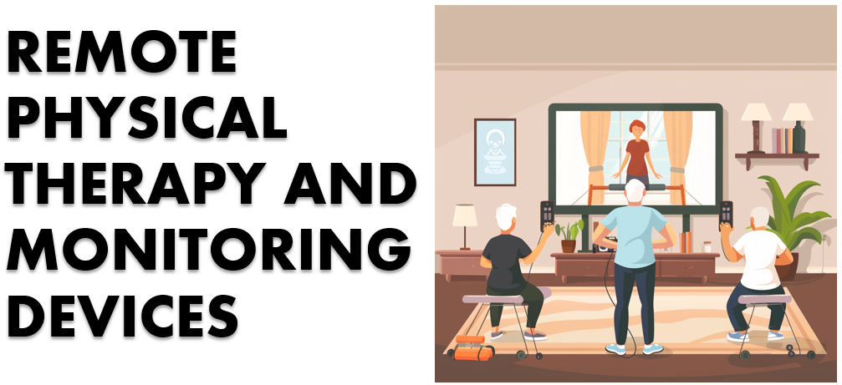
This section shows examples of products and services related to the following concerns you may have:
- Access to physical therapy from home to improve mobility and reduce pain
- Tailored exercise routines to maintain or improve physical health
- Immediate alerts for emergencies or health issues
- Monitoring heart rate and sleep to ensure heart health and restful nights

Smart Watches can keep track of your activity levels and offer location services to ensure your safety (Image Source)
Remote physical therapy sessions and wearable movement trackers are essential for your well-being. Remote physical therapy allows you to receive expert guidance from the comfort of your home. With remote sessions, therapists can create personalized exercise routines based on your specific needs. Regularity is crucial for effective physical therapy. Remote sessions encourage consistent participation, ensuring that you stick to your prescribed exercises and achieve better outcomes.
Wearable motion trackers monitor steps, heart rate, sleep patterns, and more. Wearables also provide visual feedback, encouraging you to stay active and meet your goals. Early detection of irregular heartbeat or falls allows you to seek timely medical attention to prevent potential complications.
- OneStep is a recommended platform for remote physical therapy.
  - OneStep:
    - Offers digital care powered by motion intelligence.
    - Provides gait analysis, which is crucial for health monitoring. The system operates seamlessly using your smartphone, eliminating the need for wearables or calibration.
    - Features:
      - 24/7 smartphone motion lab
      - Digital/physical intervention: Built-in chat and telemedicine suite for continuous care.
      - Home Exercise Program (HEP): Customizable exercise plans
- Wearable monitoring devices, such as smartwatches or fitness trackers, help you keep track of your daily activity levels.
  - Letscom Smart Watch Fitness Tracker:
    - Offers good accuracy in tracking heart rate and sleep patterns.
    - High-quality, budget-friendly choice.
    - Track your outdoor activities and monitor your routes with the GPS function.
    - Connect to your phone for calls and messages.
    - Saves data, allowing you to monitor your progress over time.

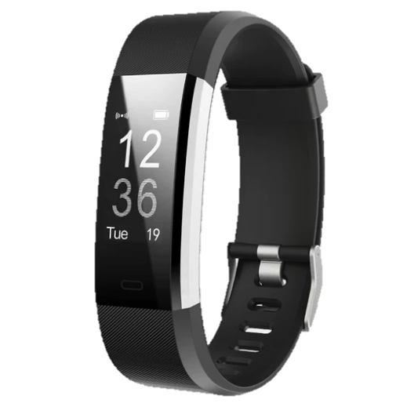

ADDITIONAL RESOURCES:
Type | Product/Service | Price | Features
Physical Therapy Platform | OneStep | Requires consultation | Gait analysis without wearables
GPS Tracker | Withings ScanWatch | Varies based on model | ECG and SpO2 monitoring  Detects irregular heartbeats and sleep apnea
 | Bodimetrics Prevention Circul + Ring | $299 | Blood oxygenation and heart rate tracking  Monitors sleep dynamics, temperature, steps, and calories
 | Garmin vívoactive® 4S | Varies based on model | Fitness tracking  Health monitoring  Built in GPS
Fitness Tracker | Letscom Smart Watch Fitness Tracker | $34.99 | Affordable  Tracks steps heart rate, and sleep
 | 3DActive 3DFitBud Step Counter | $39.99 | Affordable  Basic step counting
 | Realalt 3DTriSport Walking 3D Pedometer | $29.99 | Affordable  Basic step counting

ENHANCING SENIOR HEALTHCARE THROUGH TELEMEDICINE

Today, technology helps us connect in many ways, and it's especially helpful for older adults to access medical care online. Telemedicine services, such as those discussed in this guide, are instruments to make remote medical care possible. As we get older, our health needs change, and telemedicine can give personalized help that allows you to look after your own health better.

Telemedicine makes it easier for you to talk to doctors, no matter where you are, improves how we talk about health, and encourages us to take care of our health sooner. As we start using more digital tools, it's important to make sure everyone knows how to use them. By working together, we can build a future that's healthy and more connected for everyone.

HOW TO GET STARTED

“EMBRACING TELEMEDICINE”
Are you ready to set up your telemedicine appointment? Follow these steps to get started:
Technology Required:
- Device (smartphone, computer, or tablet)
- Internet Connection (Wi-Fi or mobile data)

- Prepare Your Space:
  - Find a quiet, well-lit area in your home.
  - Make sure your device is charged.
    - How Do I Know if my Device is Charged?
Three battery icons in order of charge level; the black bar inside the battery indicates how full the battery is:
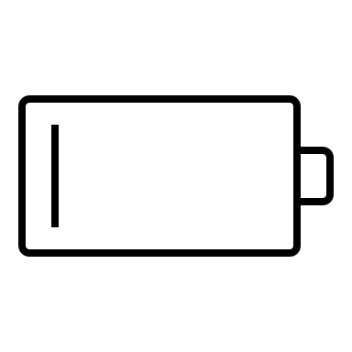
An icon indicating that your device is currently charging:

- Choose Your Device:
  - If you have a smartphone or tablet, that’s great! If not, a computer with a webcam will work too.
- Internet Connection:
  - Connect to Wi-Fi on any device or use mobile data on a smartphone.
  - Stable internet is important for clear video calls.
- Practice Beforehand:
  - Familiarize yourself with your device before your appointment by making sure you can confidently:
    - Turn it on
    - Adjust the volume
    - Use the camera
  - Practice making a video call with a loved one to get comfortable.
- Schedule Your Telemedicine Appointment:
  - Call your doctor’s office or sign up for a telemedicine platform.
  - Choose a time that works best for you.
- Join the Appointment:
  - At the scheduled time, open the telemedicine app or website.
  - Allow access to your camera and microphone when prompted.
- During the Visit:
  - Share your symptoms, concerns, and medications you’re taking.
- Write It Down:
  - Take notes during the visit. Write down instructions, next steps, and any changes to your treatment plan.
- Follow-Up:
  - If needed, schedule a follow-up appointment.
  - Keep your device charged and ready for the next appointment.

